The Impact of Industrial Parks on Local Labour Markets: Evidence from Ethiopia
Tevin Tafese^{1,2} and Alisha Weber³

¹ German Institute for Global and Area Studies, Hamburg, Germany
² Georg-August Universität Göttingen, Germany
³ German Institute of Development and Sustainability
June 2025

Abstract
Over the past decade, the Ethiopian government has vigorously pursued the establishment of industrial parks (IPs) as a cornerstone of its economic transformation and industrialisation strategy. This paper examines the spatial impact of these IPs on local labour markets combining georeferenced data on IPs, compiled from historical satellite imagery, with rich micro-level data on Ethiopian workers from three waves of the Ethiopian National Labour Force Survey for the period 2005-2021. Using a concentric ring approach and a difference-in-differences design, we find that the expansion of Ethiopian IPs led to a strong shift away from own-account and unpaid family work in agriculture towards wage work in construction in locations close to expanding IPs. We also find a modest increase in employment in manufacturing, driven by textile and apparel, but not in services. Finally, we find no robust evidence of higher earnings for the subset of wage workers around expanding IPs.
JEL classification: J23, J24, J30, J80, O14, O17, O19, P33
Keywords: Ethiopia, Industrial Parks, FDI, Labour markets, Structural change, Informality

Introduction
The Ethiopian government has identified industrialisation as a means to transform the economy and reduce poverty while creating jobs for its rapidly growing population (World Bank, 2019). One of the key policy instruments for Ethiopia’s structural transformation has been the development of industrial parks (IPs) (Tang, 2022). The establishment of the Eastern Industrial Zone (EIZ), Ethiopia’s first industrial park, in 2007 marked the beginning of the development and expansion of IPs in Ethiopia (Giannecchini and Taylor, 2018). Since then, 26 IPs have been established or planned with the primary objective of attracting foreign firms in labour-intensive and export-oriented light manufacturing, particularly in the textile and apparel (T&A) sector. Through a concerted effort by the government and various agencies, even global brands such as H&M and PVH have been attracted to IPs. This has contributed to a massive increase in FDI inflows, which tripled from $1.3 billion in 2013 to $4.3 billion in 2021 (UNCTAD, 2022), the period in which most of Ethiopia’s IPs were established. As the attracted FDI firms mainly produce for global markets, exports of T&A more than tripled over the same period, from $38.7 million in 2013 to $143 million in 2021 (ITC, 2024).
Despite this macroeconomic success, working conditions in Ethiopia’s emerging export-oriented T&A sector, which is mainly located in the IPs, have been the subject of much debate. Indeed, recent empirical studies have shown that factory work in the T&A sector is often poorly paid and associated with adverse health outcomes, resulting in high turnover and industrial conflict between employers and workers (Blattman and Dercon, 2018; Chu and Fafchamps, 2022; Oya and Schaefer, 2021). However, there is a lack of systematic empirical evidence for Ethiopia on the broader local impacts – beyond the creation and quality of factory work – of integration into global markets through the establishment of IPs. Yet, such evidence is essential for a more complete understanding of their economic impact (Moretti, 2010). For example, recent evidence from low- and middle-income countries in Asia suggests that place-based IP policies can play a key role in inducing productivity-enhancing structural change – that is, the reallocation of workers from the traditional agricultural sector to the modern services and manufacturing sectors – and may thus lead to broad improvements in incomes and working conditions (Brussevich, 2023; Gallé et al., 2024; Hyun and Ravi, 2018; Tafese et al., 2025; Zhao and Qu, 2023). An analysis of structural change in the African context and the role of place-based policies is particularly important, as recent studies show that structural transformation in the region has exhibited distinct patterns, with relatively limited movement into manufacturing and a more pronounced shift from agriculture into low-productivity services (Diao et al., 2019, 2018, 2017; Mensah et al., 2023).
This paper addresses this gap by examining the spatial impact of IP expansion on local labour markets in Ethiopia. To do so, we combine georeferenced data on IPs, compiled from historical satellite imagery, with rich micro-level data on Ethiopian individuals from three waves of the nationally representative National Labour Force Survey (NLFS) for the period 2005-2021. Specifically, following the methodology of Tafese et al. (2025), we use historical satellite imagery from Google Earth Pro to identify the location of Ethiopian IPs and construct a continuous measure of IP exposure based on changes in the built-up area of IPs over time. We then combine this measure with individual-level NLFS data at the level of the ward (also known as kebeles), the lowest administrative unit in Ethiopia.
Using a concentric ring approach, we estimate the spatial impact of IP expansion on individuals in 10 km distance bins around IPs up to 30 km. To identify the causal effect of an increase in the built-up area of IPs on local employment, we use a difference-in-differences (DiD) framework that compares changes in the labour market outcomes of individuals living in close proximity to expanding IPs with changes in outcomes of individuals from the same district (also known as woredas), Ethiopia’s second lowest administrative unit, living further away from expanding IPs. We address the main identification concern of non-parallel trends in outcomes of places with and without expanding IPs by including a number of fixed effects, such as district fixed effects, which control for time-invariant confounders, and district-year fixed effects, which capture shocks that are common to all individuals in the same district in the same year. In addition, we test whether wards at different distances from IPs had different pre-treatment trends before the IP establishment by running placebo regressions using the pre-treatment waves of our NLFS data going back to 2005, well before any IPs were planned. Our results for most outcome variables are robust to various extensions using alternative samples, treatments, and outcomes, as well as accounting for migration.
We have three sets of results. First, we document significant shifts in employment around expanding IPs, particularly within 10 km. We find a strong movement away from unpaid family work towards self-employment and wage employment in private enterprises. In line with this, there is a large decrease in employment in agriculture around expanding IPs and a large increase in employment in construction. We also document a modest increase in employment in manufacturing, which is driven entirely by T&A, but no significant impact on employment in services. Second, for the subset of wage workers for whom earnings data are available, we find positive effects on wages. However, these are only marginally statistically significant and not robust across different specifications. We therefore caution against over-interpreting this (non-)finding, which may well be due to the lack of earnings data beyond wage workers. Third, the documented sectoral changes apply to both men and women, although men tend to move mainly from own-account work to wage work, while women tend to move mainly from unpaid family work to wage work.
Our work contributes to three strands of the literature. First, we contribute to a growing body of work that examines the economic impact of place-based policies, particularly Special Economic Zones (SEZs), in developing countries. While existing studies have almost exclusively focused on the impact of place-based policies in Asian economies, we are, to the best of our knowledge, the first to provide rigorous micro-level quantitative evidence for an African country. Our findings complement the evidence on these Asian countries well, particularly with respect to structural changes in employment in exposed locations. Consistent with the evidence on Cambodia (Brussevich, 2023), China (Zhao and Qu, 2023), India (Gallé et al., 2024; Hyun and Ravi, 2018), and Vietnam (Tafese et al., 2025), we find a large decline in agricultural employment in ‘treated’ locations around expanding IPs in Ethiopia. For manufacturing and services, the literature is more mixed. Similar to the evidence from India and Vietnam, we find a shift towards manufacturing employment in treated locations in Ethiopia, but this shift is more moderate than in the other two countries. In contrast to all other studies, we find the strongest shift towards construction. Additionally, similar to the evidence from Vietnam, we find no impact on employment in services, diverging from the findings in Cambodia and India.
Second, we contribute to a recent wave of studies focusing on the local impact of investment and trade liberalisation on economic outcomes in Ethiopia. Focusing on the impact of greenfield FDI, Abebe et al. (2022) find positive employment spillovers in local manufacturing firms due to the opening of FDI projects. This is partly confirmed in another study by Crescenzi and Limodio (2021), which focuses specifically on Chinese greenfield FDI. They find that employment in local manufacturing firms expands in up- and downstream sectors, while it contracts in local firms in the same sector because of increased competition. Afesorgbor et al. (2023) corroborate the potentially adverse impact of foreign competition – in their case from Chinese imports – which is associated with negative effects on female employment and male wages in manufacturing. More broadly, however, Chen et al. (2025) show that Chinese greenfield FDI has played an modest role in supporting industrialisation in Africa, albeit with effects that vary based on country characteristics such as institutional quality and local capacity. While the results of these studies are broadly consistent with the moderate increase in manufacturing employment in treated locations that we find, we also capture shifts across sectors using our individual-level labour market data. Our approach is thus closely related to that of Giovannetti et al. (2022) who also focus on local labour market outcomes from the same individual-level NLFS, but analyse the impact of Ethiopia’s trade liberalisation in the late 1990s and early 2000s. Similar to our findings, the authors find only small shifts to manufacturing in districts with larger reductions in output tariffs, but unlike us they find the largest shift from agriculture to services, especially for women.
Third, we contribute to a literature that examines the working conditions and welfare effects of factory work, particularly in Ethiopia’s export-oriented T&A sector in the IPs. This literature generally highlights the often poor working conditions in this sector. For example, Chu and Fafchamps (2022) and Oya and Schaefer (2021) use specially designed surveys to document high turnover and industrial conflict between (foreign) employers and workers in IPs. In addition, Abebe et al. (2020) and Blattman and Dercon (2018) provide experimental evidence of short-term negative effects of industrial work on health outcomes. However, long-term follow-up studies show no negative effects of factory work on working conditions or health outcomes, but also that it does not provide better pay than other income-generating opportunities (Abebe et al., 2024; Blattman et al., 2022). In contrast to these studies, our results show that integration into the global economy has had a broader impact on work patterns in Ethiopia, extending beyond the manufacturing sector. The establishment of IPs has shifted employment from agriculture to modern sectors, mainly construction and partly manufacturing. This highlights the importance of considering the wider local effects of global market integration.
The rest of the paper is organised as follows. Section 2 describes the policy background and presents the characteristics of IPs in Ethiopia. Section 3 presents the data and summary statistics. Section 4 discusses the empirical strategy. Section 5 presents the empirical findings. Section 6 performs robustness checks and extensions. Finally, Section 7 concludes the paper.

Policy Background
Over the past decade, the Ethiopian government has vigorously pursued the establishment of IPs as a cornerstone of its economic transformation and industrialisation strategy. Based on various public sources, we have identified 26 IPs across the country, of which 19 are public and 7 are private (see Figure 1). Every region of Ethiopia has at least one IP, although most of these IPs are located in the central provinces of Oromiya, and Amhara, and in the capital, Addis Ababa. Ethiopia’s first two IPs, the private EIZ and the public Bole Lemi IP, were established in 2007 and 2014 respectively. All other IPs were established after 2016. To date 20 IPs have been opened and 6 are still in the planning stage.
Figure 1: Ethiopia's IPs
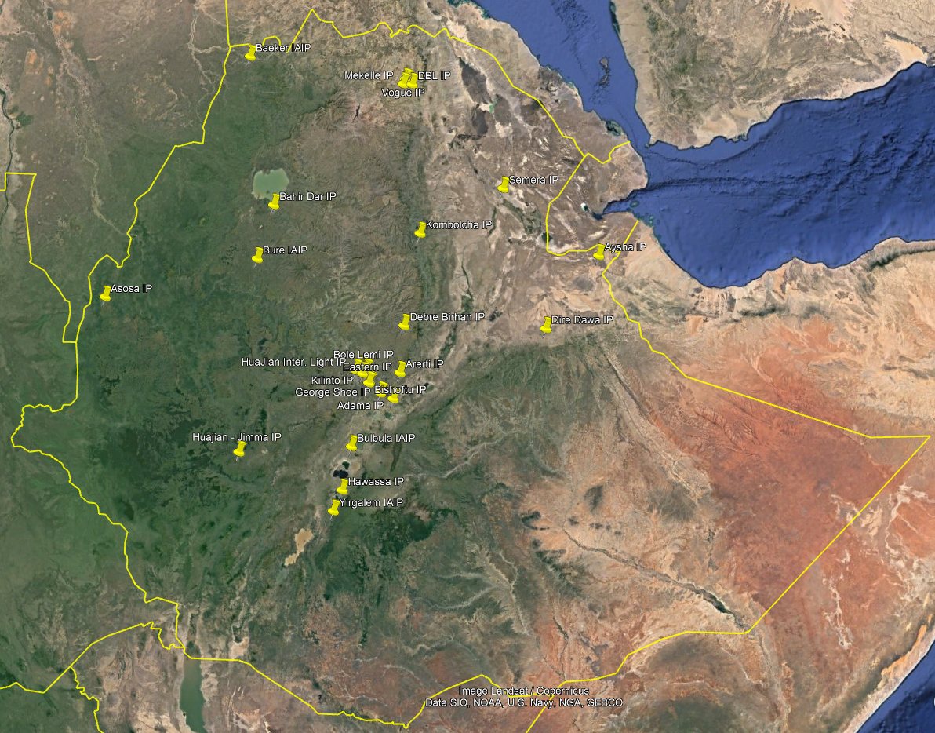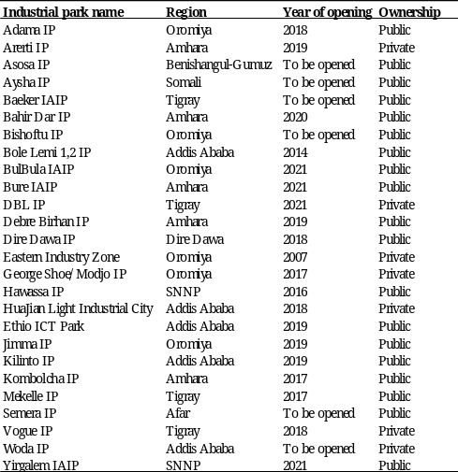
Note: The geographical map of Ethiopia is from Google Earth Pro (left). The list of IPs and their key characteristics is compiled from various Ethiopian agencies and other public sources (right).
Ethiopia’s IPs are almost exclusively populated by foreign firms, as firms located in IPs are generally required to export their entire output in order to benefit from the preferential tax and customs regimes of IPs (ILO and IFC, 2023). Using project-level data from the Ethiopian Investment Commission (EIC), the left panel of Appendix Figure 1 shows that the cumulative number of licensed foreign investment projects located in IPs began to rise sharply in the early 2010s, from 8 in 2010 to 178 in 2021 – about a decade after foreign investment inflows to Ethiopia generally began to rise. In terms of their sectoral focus, 96 per cent of the foreign investment projects inside IPs are manufacturing projects, compared to 62 per cent of projects outside IPs. Moreover, manufacturing projects in IPs tend to focus on labour-intensive T&A manufacturing, which accounts for more than half of all manufacturing projects inside IPs, compared to around 12 per cent outside IPs. As a result, projects inside IPs on average create significantly more jobs, both permanent (354 vs. 216) and temporary (427 vs. 143) (see right-panel in Appendix Figure 1) than projects outside IPs.
The promotion and development of IPs is guided by Ethiopia’s five-year Growth and Transformation Plans (GPT), with three agencies in particular taking the lead across several policy areas. First, the Ethiopian Investment Board (EIB), which is chaired by the Prime Minister and comprises senior ministers from other key ministries, oversees Ethiopia’s investment promotion and IP policy, including the provision of incentives to investors, the removal of policy and regulatory barriers to investment, and the designation of new IPs. Second, the EIB-supervised EIC focuses on the day-to-day operations of foreign investment promotion, such as advising the government on improving the investment climate and administering investment and work permits related to the IPs. Third, the Industrial Parks Development Corporation (IPDC), a for-profit state-owned enterprise (SOE), is tasked with developing and managing the public IPs, including making land available to potential private developers and providing infrastructure and services to investors.
In summary, the Ethiopian government has placed great emphasis on creating an institutional structure that promotes strong inter-ministerial/interagency cooperation for investment promotion and IP development, which is centrally coordinated by the Prime Minister’s Office. This has arguably proved critical in attracting foreign investors to Ethiopia, in contrast to other African countries such as Kenya, Nigeria and Tanzania, where limited high-level government support and institutional linkages have hindered this (Rodríguez‐Pose et al., 2022).

Data
We use two main data sources to examine the impact of IPs on local labour markets in Ethiopia. First, we use IP exposure (at different distances) as our treatment variable, which we measure as the total built-up area of IPs. We construct this variable from a unique dataset of geographically-referenced Ethiopian IPs using historical, high-quality Google Earth Pro satellite imagery. This imagery is available on a regular basis – mostly annually or even more frequently – since the late 2000s, and thus for the entire period of the expansion of Ethiopia’s IPs. Second, we obtain our individual-level labour market outcomes from three waves of the nationally representative NLFS. The NLFS survey waves are from 2005, 2013, and 2021, covering the period before, during, and after the expansion of IPs, providing an ideal setting to study the local impact of the expansion of IPs on workers. In the following, we explain how we construct our treatment variable, IP exposure, from Google Earth Pro satellite imagery (Section 3.1), present our main labour market outcome variables from the NLFS (Section 3.2), and describe how we combine our treatment and outcome data and present pre-treatment summary statistics (Section 3.3).

Measuring IP exposure
We construct our main treatment variable of IP exposure from the actual built-up area of IPs that is covered by structures such as factories and sheds using historical Google Earth Pro satellite imagery, closely following Tafese et al. (2025). We measure changes in the built structures of an IP over time by drawing polygons around the factories and sheds within its well-defined boundaries in all years for which satellite imagery is available. We follow this procedure for each IP to construct our continuous IP exposure variable. As Ethiopia’s IPs have only recently been established, high-quality imagery is available almost every year – and several times a year for recent years – which also allows us to identify the start of construction for each IP.
Figure 2 shows as an example the expansion and our mapping of Ethiopia’s two largest IPs, namely the EIZ and the Hawassa IP. For both IPs, the leftmost satellite image shows the demarcated IP boundaries in the year just before construction began, when there were no built structures – 12/2009 for EIZ and 12/2014 for Hawassa. In these earliest images, the built-up area for both IPs is 0 hectares (ha). The rightmost image shows both IPs in the last year of our study period, 2021. By this time, both IPs had expanded significantly, with the EIZ covering a built-up area of 263 ha and the Hawassa IP 113 ha. The middle image shows each IP at an intermediate point, when the IPs had already begun to expand, although not to the extent seen in the last year of the study period.
Figure 2: The Expansion of Ethiopia's Two Biggest Industrial Parks
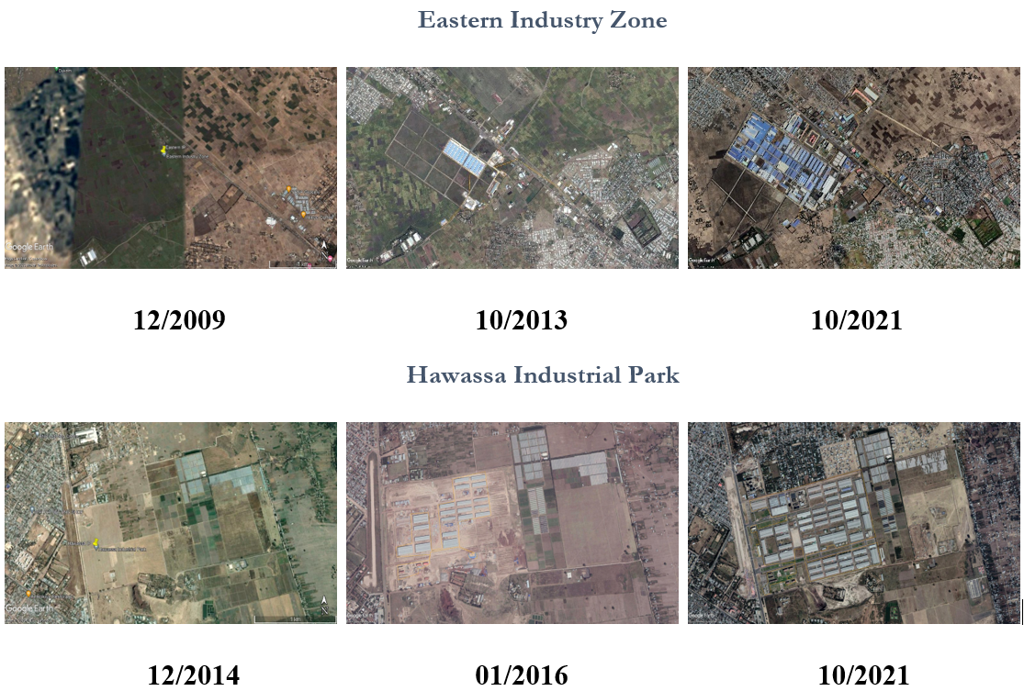
Notes: The satellite imagery is from Google Earth Pro. The figure shows the expansion of the Eastern Industry Zone and Hawassa Industrial Park over time via satellite imagery.
Table 1 summarises the expansion of Ethiopia’s IPs over our study period, showing the total built-up area for each IP in 2005, 2013 and 2021, the three years in which the NLFS waves were conducted. In 2005, there were no built-up IPs in Ethiopia. This changed by 2013, when the EIZ and Bole Lemi IP had been established, although the latter’s built-up area was still small at 4 ha. By 2021, 18 out of the 21 IPs had some built-up area, with an average of 46 ha. The size of these 18 IPs varied considerably, with 4 IPs having a built-up area of less than 10 ha, 8 IPs having a built-up area between 10 and 50 ha and 6 IPs having a built-up area of more than 50 ha. In line with this, the total built-up area of IPs in Ethiopia grew from 0 ha in 2005, to almost 4000 ha in 2021, with growth accelerating particularly in the second half of the 2010s (Appendix Figure 2).
Table 1: IP Expansion over Time
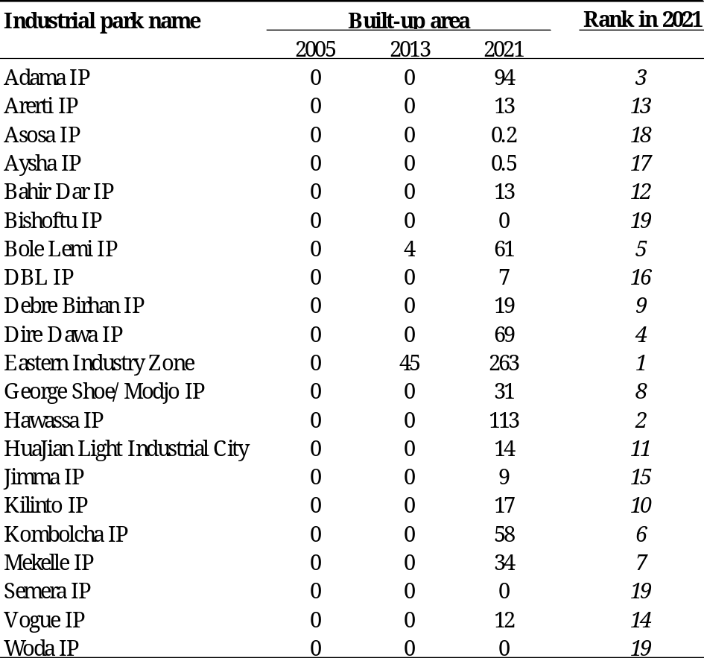
Note: Author’s own compilation based on satellite imagery from Google Earth Pro. Total built-up area is measured in hectares and includes all physical structures such as factories and sheds that fall within the boundaries of an IP.

NLFS outcome data
We use individual-level labour market outcomes from three waves of the NLFS, conducted in 2005, 2013 and 2021. The NLFS is a nationally representative survey conducted by the Ethiopian Central Statistical Agency (CSA) in all urban and rural areas. As a repeated cross-sectional survey, each wave of the NLFS samples 43,000–57,000 new households and between 170,000–240,000 new individuals. Apart from its large sample size, the main advantage of the NLFS, which allows for a careful analysis of local labour market dynamics, is its level of detail. Specifically, the NLFS provide detailed information on individuals’ employment for both the last seven days and the last twelve months, including their employment status, their occupation at the 4-digit ISCO level, and the main type and sector of employment at the 4-digit ISIC level (see Appendix Table 1 for the sectoral classification). In the baseline regression, we use the employment outcomes for the last seven days as they are generally more complete, and available at a higher level of detail. However, we also check the robustness of our results using the employment outcomes for the last twelve months. Finally, earnings data are available for a subset of individuals in wage employment for whom we can therefore analyse the impact of the expansion of IPs on wages.
The key to examining the spatial impact of IP expansion is that we geolocate the individuals in the NLFS in as much detail as possible. Although we do not know the exact geocoordinates of individuals for reasons of confidentiality, for each household in the NLFS we know the four administrative units in which it is located, which are, from top to bottom, regions, zones, districts, and wards. By matching the Ethiopian ward codes in the NLFS data to the ward codes in the geospatial Africa GeoPortal dataset, which provides the administrative boundaries of every ward in the country, we can extract geocoordinates at the lowest administrative ward level. However, due to changes in administrative codes over the time, we cannot match all ward codes across the two databases and have to manually extract the geocoordinates of many kebeles from the Africa GeoPortal and Google Maps based on their name. Overall, we are able to geolocate 74 per cent of the individuals at the ward level across the three NLFS waves.
Finally, we restrict our final regression samples in a number of ways. First, we exclude the Tigray region from the analysis because no endline data could be collected from the region, due to the outbreak of the armed conflict between forces allied to the Ethiopian federal government and the Tigray People’s Liberation Front (hereafter Tigray War) in November 2020. Second, we drop those individuals aged 5 or younger for whom no employment information was collected. Third, we drop households that could not be geolocated at the ward-level, which excludes, for example, the Somali region, for which the Africa GeoPortal platform does not provide geocoordinates at the ward level. We thus end up with 385,330 individual-level observations across the three waves of the NLFS.

Combining IP exposure and NLFS outcome data
We spatially link our measure of IP exposure to the NLFS outcome data using the geocoordinates of the IPs and individuals’ home wards. Figure 3 shows on a map of Ethiopia the location of NLFS households (yellow) and the IPs, distinguishing between those in operation (purple) and those planned (red), as well as administrative district boundaries. In total, there are 1913 unique household locations at the ward level. Most districts have multiple household locations, and in particular IPs tend to be surrounded by multiple household locations (at varying distances), as they are often located in peri-urban areas on the outskirts of towns and cities. Note, that there are no NLFS households in the northern Tigray region and the south-eastern Somali region, as we had to exclude both due to missing data for the reasons mentioned above.
Figure 3: Location of NLFS Households and IPs in Ethiopia
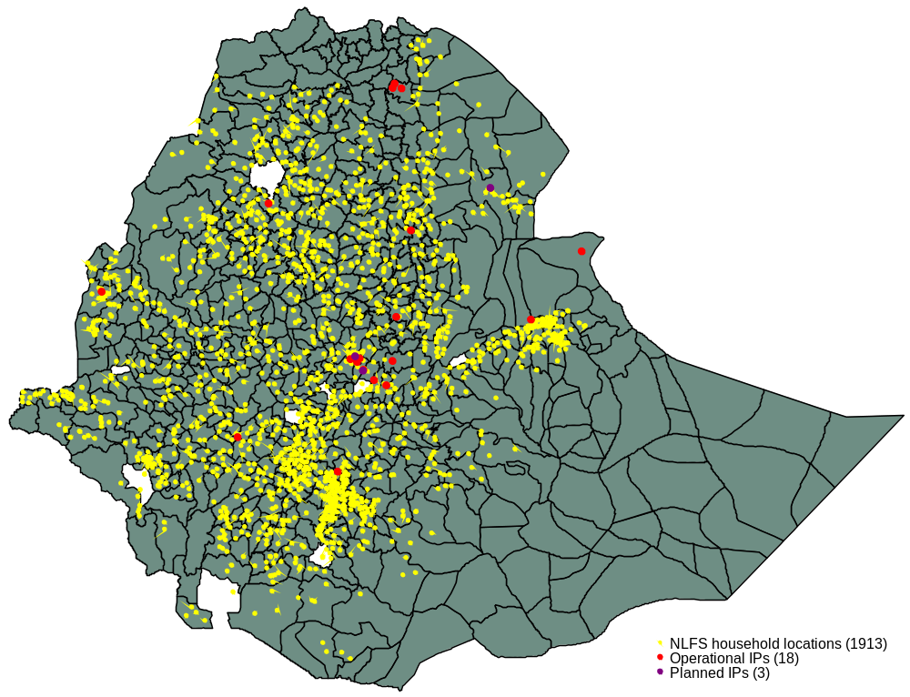
Note: Author’s own compilation based on (i) district-level administrative boundaries from the Africa GeoPortal platform, (ii) the geocoordinates of NLFS households at the ward-level from three waves of the NLFS, and (iii) the geocoordinates of IPs from Google Earth Pro.
We now examine the pre-treatment characteristics by proximity to IPs. To do this, we calculate the distance between IPs and individuals in our sample in 10 km distance bins around IPs based on the geocoordinates of IPs and individuals’ home wards. Table 2 shows the pre-treatment characteristics of individuals in 10 km distance bins for the first two NLFS waves, 2005 and 2013, which was before the expansion of most IPs in Ethiopia (see Table 1). The table shows strong differences in the characteristics of wards across distance bins. In terms of the geography and demographics, wards closer to IPs are on average more densely populated, especially those within 20 km of IPs, and individuals living very close to IPs, within 10 km, are much more likely to live in urban wards. In addition, individuals living closer to IPs are on average older and more educated. In terms of employment characteristics, wards closer to IPs have significantly higher proportions of wage employment and significantly lower proportions of own-account and unpaid family work. Correspondingly, the share of employment in private enterprises and the public sector is higher in districts close to IPs, while the share of employment in households is lower. Similarly, the share of employment in manufacturing, services and construction is higher near IPs and lower in agriculture.
Table 2: Pre-Treatment Location Characteristics
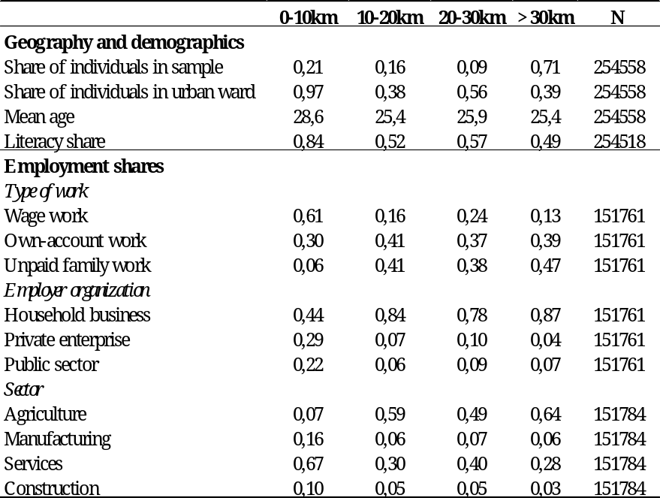
Note: Author’s own compilation based on the 2005 and 2013 NLFS waves. The distance between IPs and individuals is calculated based on the geocoordinates of IPs and individuals’ home wards.

Empirical Strategy

Concentric ring approach
We capture the spatial impact of IP expansion in a concentric ring approach using three continuous treatment variables, one for each 10 km distance bin up to a radius of 30 km around an IP. Each treatment variable captures the total built-up IP area to which an individual i living in ward w falling within the corresponding distance bin b is exposed. Formally, the three treatment variables are defined as $\sum_{b=1}^{3}{{IP_exposure}_{wt{[b}_{w}=b]}}$, where $b_{w}=1$ denotes wards falling within the 0-10 km distance bin, $b_{w}=2$ indicates wards falling within the 10-20 km distance bin, and $b_{w}=3$, denotes wards falling within the 20-30 km distance bin. ${IP_exposure}_{wt}$ is the same for all individuals in the same ward, but varies over time with changes in the total built-up IP area.
Thus, in our concentric ring approach, individuals living more than 30 km away from all IPs are in the control group in all years. Similarly, individuals living within 30 km of a planned IP that has not yet been established are in the control group for that year. Our treatment threshold of 30 km is chosen based on evidence from similar studies, which have shown that the impacts of place-based policies tend to be highly geographically concentrated, with little or no spillovers to neighbouring places (Abagna et al., 2024; Gallé et al., 2024; Görg and Mulyukova, 2024; Lu et al., 2019; Tafese et al., 2025). In the Ethiopian context, characterised by low incomes, transport costs are likely to be an even greater constraint on commuting, making spillovers even less likely than in the context of the above studies.

Baseline specification
To estimate the spatial impact of IP expansion on our individual-level labour market outcomes, we pool the three NLFS waves from 2005, 2013, and 2021 and adopt a DiD design, which we implement using the following two-way fixed effects (TWFE) regression specification:
$y_{iwdt}=β_{0}+\sum_{b=1}^{3}{β_{b}}{IP_exposure}_{wt{[b}_{w}=b]}+ β_{4}IX_{iwdt}+β_{5}IY_{wd}+γ_{t}+γ_{d}+ γ_{dt}+ε_{idt}$ (1)
where $y_{iwdt}$ is the outcome of interest for individual i living in ward w in district d at time t. As explained above, $\sum_{b=1}^{3}{{IP_exposure}_{wt{[b}_{w}=b]}}$ are our three treatment variables and $β_{1},β_{2,}$ and $β_{3}$ therefore the main coefficients of interest, which capture the effect of an increase in IP built-up area on individuals within 0-10 km, 10-20 km, and 20-30 km of an IP, respectively. We measure IP exposure in 10 ha, which is about twice the median built-up area of IPs in 2021 (see Table 1).
$IX_{iwdt}$ is a vector of time-varying individual-level controls, including an individual’s age, a male dummy, and a categorical variable for an individual’s highest educational attainment. $IY_{wd}$ is a vector of time-invariant ward-level controls, including three dummy indicators for the 0-10 km, 10-20 km, and 20-30 km distance bins around established IPs that capture whether an individual is in one (or more) of the three treatment groups, and a rural dummy that captures whether the ward is in a rural area (i.e. it is a village) or an urban area (i.e. it is a town).
We also include $γ_{t}$ year fixed effects, $γ_{d}$ district fixed effects, $γ_{dt}$ district-year fixed effects. We include district fixed effect even though our treatment varies at the ward-level because most districts are consistently available across all three NLFS survey waves, whereas wards tend to change between survey waves. While the district fixed effects control for time-invariant differences in the characteristics of districts, such as their size and geographical location, the district-year fixed effects capture shocks that are common to all individuals in the same district in a given year. Importantly, the district-year fixed effects also capture shocks that may be correlated with baseline district characteristics. Finally, $ε_{idt}$ is the error term, which is clustered at the district level.

Identification
Equation (1) identifies the spatial impact of IPs from the correlation in the changes in outcome variables of individuals living in wards that are (more) exposed to IPs and comparable individuals living in comparable wards, in terms of baseline individual- and ward-level characteristics, that are (less or) unexposed to IPs in the same district. The main threat to the identification of the causal parameters of interest $β_{1}$, $β_{2}$, and $β_{3}$ is a violation of the assumption of parallel trends. This would be the case if IPs were systematically established in places whose trends in (labour market) outcomes would have differed from those of places without IPs in the absence of the intervention. Although the selection of sites for IPs is based on a distributional approach, with each region in Ethiopia receiving an IP, within regions selected sites may be on different outcome trend paths than unselected sites – indeed, this is likely, as the accessibility to regional airports, railways and roads is an important selection criterion.
We test whether for non-parallel trends – i.e. whether wards that are (more) exposed to IPs and those that are (less or) not exposed to IPs had different pre-treatment trends before the establishment of IPs – by running a series of placebo regressions. Our NLFS data are well suited to this, as we have two pre-treatment waves, with the earliest wave from 2005, well before any IPs were planned, let alone established. We implement our placebo regressions by interacting the final treatment exposure in each distance bin with year dummies for 2005, 2013, and 2021, closely following Lu et al. (2019). Econometrically, we replace the treatment variables in our baseline specification (1) with the following terms: $\sum_{b=1}^{3}{{IP_exposure}_{w2021{[b}_{w}=b]}}$ X $γ_{t}$. Thus, in our concentric ring approach with separate treatment effects for the 0-10 km, 10-20 km, and 20-30 km distance bins, we include a total of nine interaction terms in the placebo regressions, three interactions for each year. As a result, those individuals living within 30 km of an IP that had been established by 2021, receive a placebo treatment in the pre-treatment years 2005 and 2013, when no IP was stablished (except for EIZ and Bole Lemi in 2013).
Finally, note that our empirical strategy implicitly accounts for two remaining identification assumptions that must hold for the identification of our causal parameters $β_{1}$, $β_{2}$, and $β_{3}$ (see Roth et al., 2023 for a recent review). First, by capturing potential spillover effects on individuals in wards up to 30 km away from IPs in our concentric ring framework, we ensure that the stable unit treatment values assumption (SUTVA) is unlikely to be violated. Indeed, in line with previous evidence on the spatial effects of place-based policies, we also find that the effects are most concentrated in the vicinity of IPs within 10 km, and dissipate rapidly with increasing distance from IPs. Second, although the establishment and expansion of IPs in Ethiopia was “staggered”, i.e. there was variation in the timing of treatment, we use a design that is closer to the classical two-by-two DiD approach, with essentially only a single post-treatment period, which ensures that the assumption of homogeneous treatment effects is not required for causal identification.

Results
We first examine the impact of IP expansion on structural changes in employment (Section 5.1). We then focus on the impact of IP expansion on wages (Section 5.2) and examine the differential impact for men and women (Section 5.3). Finally, we run placebo regressions to test for non-parallel trends in outcomes between locations that are (more) exposed and (less or) not exposed to IPs (Section 5.4).

Structural changes in employment
We analyse the impact of IP expansion on structural changes in employment using labour market outcome data on the type and sector of employment of individuals. We present the results of estimating specification (1) in Figure 4 and Figure 5, using separate box plots for the different outcome variables. The coefficients $β_{1}$, $β_{2}$, and $β_{3}$ are shown as blue dots in the box plots and represent the effect of a 10 ha increase in built-up area in the 0-10 km, 10-20 km, and 20-30 km distance bins respectively, with blue vertical lines indicating 95 per cent confidence intervals.
The left-hand panel of Figure 4 shows that there is a statistically highly significant (at the 1 per cent level) 1.7 p.p. decrease in the probability of employment (in the last seven days) for every 10 ha increase in the built-up area of IPs within 10 km of expanding IPs. Focusing only on working individuals, the three remaining plots show even stronger and highly significant (at the 5 per cent level or below) changes in the characteristics of employment around expanding IPs: each 10 ha increase in the built-up area of IPs is associated with a 1.5 p.p. and 2.5 p.p. decrease in own-account and unpaid family work, respectively, and a 3.9 p.p. increase in wage work within 10 km of expanding IPs. Except for the moderate effect on the probability of wage work in the 10-20 km distance bin, all effects dissipate and become insignificant beyond 10 km from expanding IPs. Consistent with these changes in employment type, Appendix Figure 3 shows a 3.9 p.p. decrease in employment in household businesses and a 3.2 p.p. increase in the employment in private enterprises within 10 km of expanding IPs.
Figure 4: Spatial Impact of IP Exposure on Type of Employment
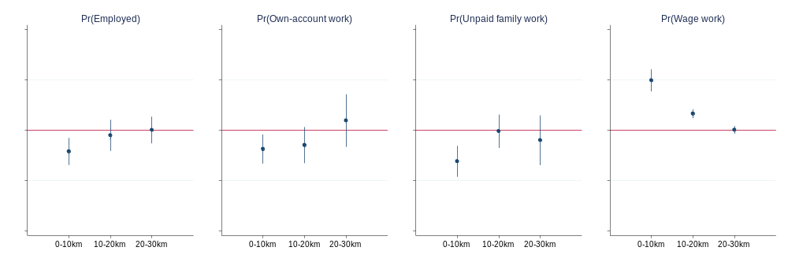
Note: Each plot shows the regression results of estimating specification (1). The leftmost plot uses as the dependent variable a dummy indicator for whether an individual has worked in the last seven days, and the other three plots use dummy indicators for the type of employment of individuals. The first plot includes all surveyed individuals, while the three other plots include only individuals in employment. The blue dots indicate the coefficient estimates of $β_{1}$ to $β_{3},$representing the effect of a 10 ha increase in built-up area in the corresponding 10 km distance bin, and the blue vertical lines indicate 95 per cent confidence intervals. N=384,879 for this leftmost plot and N=214,161 for the three other plots.
Looking at sectoral changes in employment, Figure 5 shows a large and statistically highly significant (at the 1 per cent level) shift in employment from agriculture to construction within 10 km of expanding IPs, with the former decreasing by 5.8 p.p. (or 85 per cent) and the latter increasing by 3.7 p.p. (or 32 per cent). We also see a modest 0.9 p.p. (or 6 per cent) but statistically highly significant (at the 1 per cent level) increase in manufacturing employment within 10 km of expanding IPs, which, as might be expected, is entirely driven by textile manufacturing (Appendix Figure 4). Employment in services, on the other hand, is not affected by the expansion of IPs. In line with these sectoral changes in employment, we see shifts in the workplace of individuals from farm work to factory and home work in the vicinity of expanding IPs (Appendix Figure 5).
Figure 5: Spatial Impact of IP Exposure on Sector of Employment
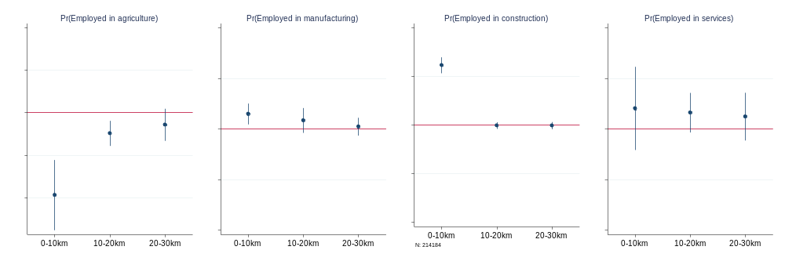
Note: Each plot shows the regression results of estimating specification (1), using as the dependent variable dummy indicators for the sector of employment of individuals. Only individuals in employment are considered. The sectoral classifications follow ISIC Revision 4 codes (see Appendix Table 1). The blue dots indicate the coefficient estimates of $β_{1}$ to $β_{3},$representing the effect of a 10 ha increase in built-up area in the corresponding 10 km distance bin, and the blue vertical lines indicate 95 per cent confidence intervals. N=214,184 for all four plots.

Wage impacts
This section investigates whether the expansion of IPs has affected local earnings. As earnings data are only available for the subset of workers in wage employment but not for those in own-account self-employment, the sample size in the following regressions is smaller than in the previous analyses. We estimate two types of regressions: one without and one with 4-digit ISIC sector fixed effects, to identify the total and ‘within-sector’ changes in wages associated with IP expansion across distance bins.
The left-hand panel of Figure 6 shows that a 10 ha expansion of IPs increases total wages by 5.3 per cent within 10 km of expanding IPs, which dissipates with increasing distance from IPs. However, the effect is only statistically significant at the 10 per cent level. When we include 4-digit ISIC sector fixed effects, the size of the coefficient falls and becomes statistically insignificant even within 10 km of IPs, as shown in the right-hand panel of Figure 6. Taken together, there is only weak evidence of overall wage growth and no evidence of within-sector wage growth around expanding IPs.
Figure 6: Spatial Impact of IP Exposure on Wages
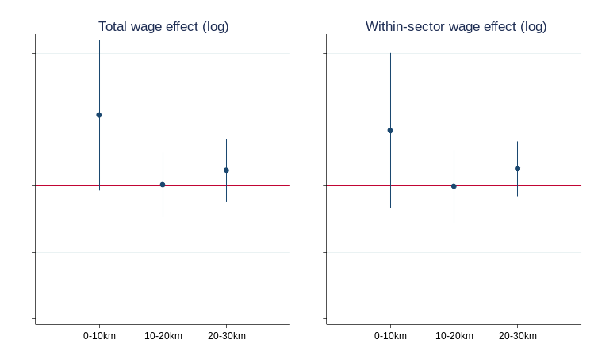
Note: Each plot shows the regression results of estimating specification (1) using log wages as the dependent variable. Only individuals in wage employment are considered. The left-hand plot does not include 4-digit sector fixed effects (ISIC Rev. 4 codes), while the right-hand plot does. The blue dots indicate the coefficients estimates of $β_{1}$ to $β_{3},$representing the effect of a 10 ha increase in built-up area in the corresponding 10 km distance bin, and the blue vertical lines indicate 95 per cent confidence intervals. N=52,522 for the left plot and N=45,454 for the right plot.

Gendered impacts
Gender is perhaps the most important dimension along which the impact of place-based policies can vary. For example, Gallé et al. (2024), Zhao and Qu (2023), and Tafese et al. (2025) show for India, China, and Vietnam, respectively, that women benefit disproportionately from SEZ policies and the induced structural shifts from agriculture to non-agriculture, especially manufacturing. Moreover, we know from the LFS microdata as well as specially designed surveys on industrial work in Ethiopia (Oya and Schaefer, 2021) that women dominate the export-oriented T&A sector and thus may be disproportionately affected by the expansion of IPs. To examine the differential impact of IP expansion by gender, we interact our three treatment variables in equation (1) with a male dummy.
Overall, men and women are affected very similarly by the expansion of IPs. Figure 7 shows that both experience a decrease in the probability of employment within 10 km of expanding IPs, which is slightly stronger for women than for men. There is also a decrease in own-account and unpaid family work for both men and women, although men tend to leave own-account work while women tend to leave unpaid family work. Finally, there is a roughly equal increase in wage work for men and women.
Figure 7: Spatial Impact of IP Exposure on Type of Employment by Gender
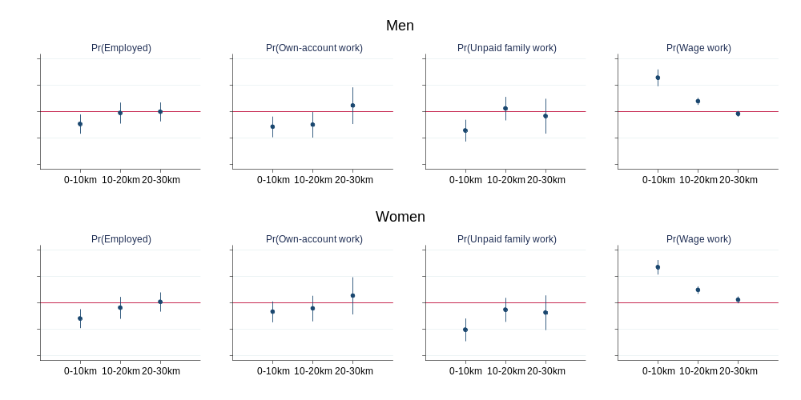
Note: Each plot shows the regression results of estimating specification (1) with interaction terms between the three treatment variables and a male dummy. The leftmost plot uses as the dependent variable a dummy indicator for whether an individual has worked in the last seven days, and the other three plots use dummy indicators for the type of employment of individuals. The first plot includes all surveyed individuals, while the three other plots include only individuals in employment. The blue dots indicate the coefficient estimates of $β_{1}$ to $β_{3},$representing the effect of a 10 ha increase in built-up area in the corresponding 10 km distance bin, and the blue vertical lines indicate 95 per cent confidence intervals. N=384,879 for the leftmost plot and N=214,161 for the three other plots.
Similar patterns for men and women are also reflected in the sectoral employment shifts around expanding IPs in Figure 8. While women are slightly more likely to leave agriculture and men are slightly more likely to enter construction within 10 km of expanding IPs, these differences are economically small. We also do not observe any statistically or economically significant differences in the impact of IP expansion on manufacturing employment, in contrast to the findings of many of the studies cited above. Finally, there is a marginally statistically significant total wage effect for both men and women within 10 km of expanding IPs, but again no statistically significant within-sector wage effect for either group (Appendix Figure 6).
Figure 8: Spatial Impact of IP Exposure on Sector of Employment by Gender
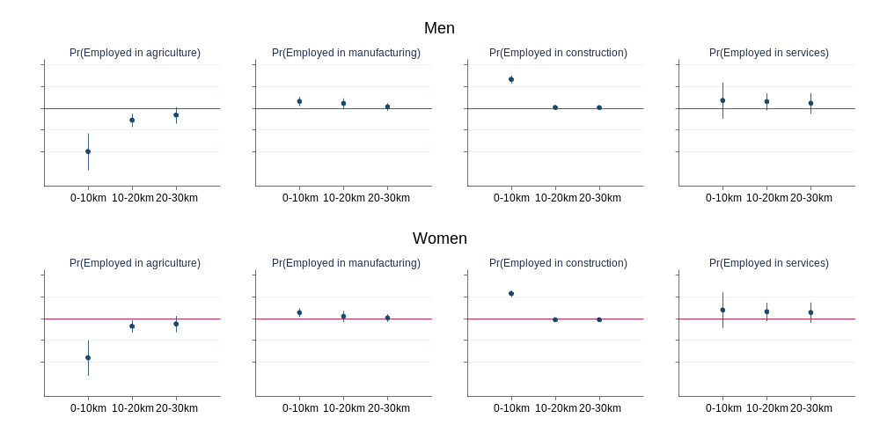
Note: Each plot shows the regression results of estimating specification (1) with interaction terms between the three treatment variables and a male dummy, using as the dependent variable dummy indicators for the sector of employment of individuals. Only individuals in employment are considered. The sectoral classifications follow ISIC Revision 4 codes (see Appendix Table 1). The blue dots indicate the coefficient estimates of $β_{1}$ to $β_{3},$representing the effect of a 10 ha increase in built-up area in the corresponding 10 km distance bin, and the blue vertical lines indicate 95 per cent confidence intervals. N=214,184 for all four plots.

Placebo egressions
As discussed in Section 4.3, the main threat to identifying a causal effect of IP expansion is a violation of the assumption of parallel trends. We analyse trends in pre-treatment outcomes, i.e. before the establishment of IPs, in wards that were later (more) exposed to IPs compared to those that were (less or) not exposed to IPs. To do this, we regress our main outcomes on nine terms that interact the ‘final’ total IP built-up area in 2021 with survey year dummies from 2005, 2013, and 2021. In the absence of differential trends in pre-treatment outcomes between treated and untreated wards, the coefficients on the placebo interaction terms with the year dummies for 2005 and 2013 should be statistically insignificant or economically small, as no IPs had been established at that time.
There are two main findings from our placebo regressions, which we report in Table 3. First, there are no significant differential trends in most pre-treatment outcomes, as the coefficients on most of the placebo interaction terms with the year dummies for 2005 and 2013 are either statistically insignificant or economically small (below 0.01 p.p.). However, columns 1 (probability of being employed) and 9 (log wages) are notable exceptions, as the placebo interaction terms are sometimes highly statistically and economically significant. Second, the actual treatment interaction terms with the year dummy for 2021 are very similar in magnitude and statistical significance to our baseline effects for most outcomes. In particular, the similar coefficients on the treatment interaction terms with the year dummy for 2021 for the 0-10 km distance bin reinforce our baseline findings. The effects of IP expansion on the probability of being employed and on wages are again the exception. For the former the effects cancel each other out within the 0-10 km and 10-20 km distance bins, and for the latter the treatment effects are now negative, although not statistically insignificant. In summary, the placebo regressions support our baseline findings of a significant impact of IP expansion on the type and sector of employment, but suggest that the estimated effects on the probability of being employed and log wages should be interpreted with caution due to their sensitivity to specification and lack of robust statistical significance.
Table 3: Placebo Regressions
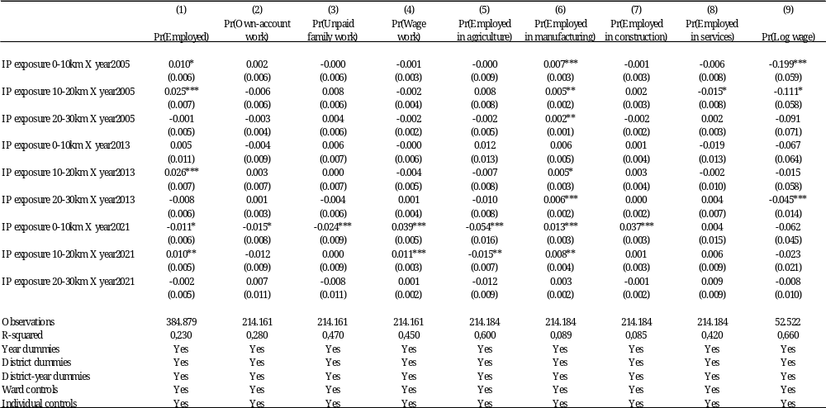
Notes: The reported results are based on estimating the district-level specification (1). Column 1 includes all surveyed individuals, columns 2-8 include only individuals in employment, and column 9 includes only wage workers. Standard errors are reported in parentheses, clustered at district level. ***p < 0.01, **p < 0.05, *p < 0.1.

Robustness and Extensions
In this section, we perform various robustness checks using alternative outcome variables, treatment variables, and samples. We also examine migration around expanding IPs and whether it drives our baseline results. Due to space limitations, we focus only on the indicators for the type and sector of employment of individuals, for which robust effects are also documented in our baseline and placebo regressions.

Alternative outcomes
We re-run specification (1) with alternative outcomes to test the sensitivity of our results to two recent adverse shocks to the Ethiopian economy and in particular to its export-oriented T&A manufacturing sector (ILO and IFC, 2023). First, the outbreak of the Covid-19 pandemic in March 2020 has led to significant order cancellations by global buyers sourcing from (foreign) suppliers in the Ethiopian IPs (Mengistu et al., 2020) and to massive layoffs of workers, particularly women and migrants, in some IPs (Hardy et al., 2024; Meyer et al., 2021). The second shock came with the outbreak of the Tigray War in November 2020, which led to the closure of all factories in IPs in Tigray, which we exclude from our empirical analysis. As a result of this war, Ethiopia lost its status as a beneficiary of the African Growth and Opportunity Act (AGOA) on 1 January 2022, i.e. after the 2021 wave of the NLFs had been implemented. With the vast majority of Ethiopian T&A exports going to the US market (e.g., 73 per cent in 2021), the loss of AGOA status led to significant order cancellations, factory closures, and job losses in Ethiopian IPs (ILO and IFC, 2023; Reuters, 2021).
Because of these shocks, one concern is that our 2021 NLFS outcome data reflect the economic realities in Ethiopia at an idiosyncratic point in time that was heavily influenced by one of these two shocks. We therefore re-run specification (1) using as outcomes individuals’ employment in the last twelve months rather than in the last 7 days, i.e. including the period prior to the outbreak of the Tigray war and even the outbreak of the Covid-19 pandemic. Appendix Table 2 shows that using employment outcomes referring to the last 12 months, instead of the last 7 days, produces results very similar to our baseline, although sometimes slightly smaller (especially for agriculture, which becomes insignificant).

Alternative treatment variables
We test the robustness of our novel treatment measure by using two alternative measures of IP exposure that we derive from the EIC project-level foreign investment data referred to in Section 2. Specifically, we use the cumulative investment and job creation – including both permanent and temporary jobs – in each IP in the survey years as our alternative measures of IP exposure. Similar to the large differences in the built-up area across IPs (see Table 1), there are also significant differences in cumulative investment and job creation across IPs (see Appendix Figure 7). Moreover, changes in cumulative investment and job creation in IPs over time are strongly correlated with changes in their total built-up area, as shown by very strong correlations of 0.93 and 0.69.
The Appendix Table 3 and Appendix Table 4 shows the regression results using exposure to cumulative investment and job creation in IPs within the 0-10 km, 10-20 km, and 20-30 km distance bins as the treatment variables. We apply the hyperbolic sine transformation to both sets of treatment variables to account for the highly skewed distributions of cumulative investment and job creation and the many zero values. Using these alternative treatment variables produces very similar results to our baseline specification in terms of the pattern and magnitude of the estimated effects. Only the effect on manufacturing employment is no longer statistically significant when cumulative investment and job creation are used as treatment variables. Overall, the results strengthen our confidence in using the built-up area of IPs as a proxy for IP activity in our baseline specification, as it produces very similar results to using these alternative proxies.

Alternative samples
Finally, we test the sensitivity of our baseline results using different samples to estimate the impact of IP expansion. First, following Abagna et al. (2024), we use a restricted sample that only includes individuals who are ultimately exposed to an IP in 2021, i.e. the treatment group. This ensures that our estimated effects are only identified from variations in the degree of exposure to an IP, reducing concerns about the treatment endogeneity and non-parallel trends. Second, we use a restricted sample that excludes Addis Ababa, where almost a quarter of individuals in the pooled sample live within 10 km of an established IP, compared to about 6 per cent in other regions of Ethiopia. This tests whether our baseline results are driven by Addis Ababa specifically, or whether they hold more broadly across the country.
The regression results of estimating restricted samples using only the treatment group and excluding Addis Ababa are shown in Appendix Table 5 and Appendix Table 6 respectively. Both tables show that using the restricted samples produces very similar results to the baseline effects. Notably, including only the treatment group shows even stronger effects than in the baseline regressions, reflected in an even larger shift out of agriculture and a much larger shift into manufacturing alongside construction (Appendix Table 5).

Migration
Previous evidence from specially designed surveys of workers in IPs suggests that a significant proportion, and in some cases the majority, of the workers in Ethiopian IPs are recent migrants (Abebe et al., 2024; Hardy et al., 2024; Meyer et al., 2021). This is also reflected in our nationally representative NLFS data, which show that migrants who have moved to their current residence within the last 10 years are overrepresented among workers employed in the export-oriented T&A sector, typically concentrated in IPs. Beyond T&A manufacturing, our data show that migrants are also overrepresented in construction and services, and underrepresented in agriculture. Taking migration into account is therefore important to assess whether the IP-induced changes in the employment that we have documented were primarily driven by migration to locations near expanding IPs.
Appendix Figure 8 shows that the expansion of IPs does indeed lead to a moderate 0.8 p.p. (or 5 per cent) increase in migration within 10 km of expanding IPs (significant at the 10 per cent level, left panel), almost all of which is driven by recent migration within the last five years of the time of the survey (significant at the 1 per cent level, middle panel). However, the increased migration around expanding IPs does not appear to be the main driver of the IP-induced changes in employment. Appendix Table 7 shows that regressions that include only locals or non-migrants in the sample yield very similar, though slightly smaller (now insignificant for own-account work), coefficient estimates to those in the baseline regressions for IP exposure within 0-10 km of expanding IPs.

Conclusion
Ethiopia has been one of the fastest globalisers in Africa over the past two decades. This has been reflected in significant growth in FDI inflows and exports over this period. A key element in attracting foreign investors and generating export growth, particularly in the light manufacturing T&A sector, has been the establishment and expansion of more than 20 IPs across the country. As a result, Ethiopia’s IP programme and the working conditions in the new industrial jobs in these IPs have recently attracted considerable policy and academic attention.
This paper adds another facet to this growing body of evidence by examining the spatial impact of IP expansion on local labour markets in Ethiopia. To do so, we combine individual-level labour market data from the 2005, 2013, and 2021 NLFS waves at the lowest administrative level in Ethiopia with a continuous measure of IP exposure based on changes in the built-up area of IPs over time, which we construct from historical satellite imagery. We then use a concentric ring approach and a DiD design to estimate the impact of IP exposure within 10 km distance bins up to 30 km around expanding IPs.
We find that the expansion of IPs significantly changes the local employment landscape, which is highly concentrated in locations within 10 km of IPs. This is reflected in large and statistically highly significant shifts from own-account work and unpaid family work to wage work and from employment in agriculture to employment in construction. We also document a moderate shift towards employment in manufacturing near expanding IPs, which is driven entirely by T&A manufacturing, but no significant impact on employment in services. These shifts are consistent with the findings of Giovannetti et al. (2022), who also find a large employment shift out of agriculture and a moderate shift to manufacturing in places more exposed to trade liberalisation. However, unlike us, the authors find a large employment shift to services, while we find a large shift to construction. We also find positive effects on local wages, but these are only marginally statistically significant and not robust across different specifications. We caution against over-interpreting this (non-)finding, as earnings data are only available for a small subset of wage workers, but not for self-employed workers, who account for almost all workers in agriculture and a significant share in manufacturing, construction and services. Finally, the observed changes in employment sectors apply to both men and women, although men tend to move mainly from own-account work to wage work, while women tend to move mainly from unpaid family work to wage work around expanding IPs.
We account for the potential endogeneity of our treatment by including a set of district-level fixed effects in our baseline specification, controlling for time-invariant confounders and time-varying shocks. We also test for non-parallel trends in labour market outcomes of places with and without expanding IPs – the main identification concern – by running a series of placebo regressions, but find no differential pre-trends for most outcomes. Finally, we perform various robustness checks using alternative outcome variables, treatment variables, and samples, and accounting for migration. Our results remain robust to the checks and are not significantly affected by the increased migration that we document around expanding IPs.
Our findings are consistent with evidence from Asia (Brussevich, 2023; Gallé et al., 2024; Hyun and Ravi, 2018; Tafese et al., 2025; Zhao and Qu, 2023), showing that place-based industrial policies in Ethiopia are inducing structural change by shifting employment from agriculture to modern sectors of the economy. However, despite being designed to promote manufacturing-led industrialisation, Ethiopia’s IPs have so far had only a modest impact on manufacturing employment, with gains concentrated in T&A and little expansion elsewhere. This contrasts with India and Vietnam (Hyun and Ravi, 2018; Tafese et al., 2025), where IPs have contributed significantly to the manufacturing expansion and productivity-enhancing structural transformation. Moreover, unlike in Vietnam, where the expansion of IPs has led to clear earnings gains – even beyond (foreign) manufacturing (Tafese et al., 2025) – we find no robust evidence of similar effects in Ethiopia, although this may partly be due to the lack of earnings data beyond wage workers. Future research should therefore examine broader welfare effects at the household level to better understand the socio-economic impact of industrialisation in Ethiopia. Ultimately, it is still too early to judge whether Ethiopia’s IP programme has been a success or a failure. However, achieving deeper and more widespread benefits from GVC integration will likely require diversification beyond T&A into other manufacturing subsectors.

Funding
The authors gratefully acknowledge funding from Germany’s Federal Ministry for Economic Cooperation and Development (BMZ). This paper was written as part of the BMZ-funded “Research Network Sustainable Global Supply Chains”.
Data Availability Statement
The IP data that we constructed from Google Earth Pro satellite imagery on which this article is based are available in the online supplementary material. Specifically, we provide access to the polygons for each IP in the KLM file ‘Ethiopia IP Polygons’ and to the built-up area over time for each IP in the STATA file ‘Ethiopia IP Built-up Areas’. The NLFS data from the CSA cannot be made publicly available due to contractual restrictions, as it is subject to their data access policy.

References
Abagna, M.M., Hornok, C., Mulyukova, A., 2024. Place-based Policies and Household Wealth in Africa.
Abebe, G., Buehren, N., Goldstein, M., 2024. Do Factory Jobs Improve Welfare? Experimental Evidence from Ethiopia. World Bank Econ. Rev. lhae015. https://doi.org/10.1093/wber/lhae015
Abebe, G., Buehren, N., Goldstein, M., 2020. Short-Run Welfare Impacts of Factory Jobs: Experimental Evidence from Ethiopia. World Bank, Washington, DC. https://doi.org/10.1596/1813-9450-9325
Abebe, G., McMillan, M., Serafinelli, M., 2022. Foreign direct investment and knowledge diffusion in poor locations. J. Dev. Econ. 158, 102926. https://doi.org/10.1016/j.jdeveco.2022.102926
Afesorgbor, S.K., Acquah, R.E., Ayele, Y., 2023. Chinese Import Competition and Gendered Labor Market Outcomes: Evidence from Ethiopian Firm-Level Data. J. Afr. Econ. 32, 547–571. https://doi.org/10.1093/jae/ejac026
Alkon, M., 2018. Do special economic zones induce developmental spillovers? Evidence from India’s states. World Dev. 107, 396–409. https://doi.org/10.1016/j.worlddev.2018.02.028
Bilicka, K., Seidel, A., 2022. Measuring Firm Activity from Outer Space (No. w29945). National Bureau of Economic Research, Cambridge, MA. https://doi.org/10.3386/w29945
Blattman, C., Dercon, S., 2018. The Impacts of Industrial and Entrepreneurial Work on Income and Health: Experimental Evidence from Ethiopia. Am. Econ. J. Appl. Econ. 10, 1–38. https://doi.org/10.1257/app.20170173
Blattman, C., Dercon, S., Franklin, S., 2022. Impacts of industrial and entrepreneurial jobs on youth: 5-year experimental evidence on factory job offers and cash grants in Ethiopia. J. Dev. Econ. 156, 102807. https://doi.org/10.1016/j.jdeveco.2021.102807
Brussevich, M., 2023. The socioeconomic impact of Special Economic Zones: Evidence from Cambodia. World Econ. twec.13526. https://doi.org/10.1111/twec.13526
Chen, D., Isah, A.B., Gummi, U.M., 2025. Effect of Foreign Direct Investments on Industrialisation: The Case of China in Africa. J. Afr. Econ. 34, 53–79. https://doi.org/10.1093/jae/ejad026
Chu, J., Fafchamps, M., 2022. Labor conflict within foreign, domestic, and Chinese-owned manufacturing firms in Ethiopia. World Dev. 159, 106037. https://doi.org/10.1016/j.worlddev.2022.106037
Crescenzi, R., Limodio, N., 2021. The Impact of Chinese FDI in Africa: Evidence from Ethiopia. Geogr. Environ. Discuss. Pap. Ser., Department of Geography and Environment, LSE, London, UK 22.
Diao, X., Harttgen, K., McMillan, M., 2017. The Changing Structure of Africa’s Economies. World Bank Econ. Rev. 31, 412–433. https://doi.org/10.1093/wber/lhw070
Diao, X., McMillan, M., Rodrik, D., 2019. The Recent Growth Boom in Developing Economies: A Structural-Change Perspective, in: Nissanke, M., Ocampo, J.A. (Eds.), The Palgrave Handbook of Development Economics. Springer International Publishing, Cham, pp. 281–334. https://doi.org/10.1007/978-3-030-14000-7_9
Diao, X., McMillan, M., Wangwe, S., 2018. Agricultural Labour Productivity and Industrialisation: Lessons for Africa. J. Afr. Econ. 27, 28–65. https://doi.org/10.1093/jae/ejx034
Gallé, J., Overbeck, D., Riedel, N., Seidel, T., 2024. Place-based policies, structural change and female labor: Evidence from India’s Special Economic Zones. J. Public Econ. 240, 105259. https://doi.org/10.1016/j.jpubeco.2024.105259
Gebreeyesus, M., Molla, G.K., Ohno, K., Ohno, I., Uesu, S., Homma, T., 2022. Ethiopia FDI Policy Report 2022. Policy Studies Institute.
Giannecchini, P., Taylor, I., 2018. The eastern industrial zone in Ethiopia: Catalyst for development? Geoforum 88, 28–35. https://doi.org/10.1016/j.geoforum.2017.11.003
Giovannetti, G., Sanfilippo, M., Vivoli, A., 2022. Import Tariff Liberalization, Employment, and Gender in Ethiopia. J. Dev. Stud. 58, 2366–2392. https://doi.org/10.1080/00220388.2022.2075736
Görg, H., Mulyukova, A., 2024. Place-based policies and firm performance: Evidence from Special Economic Zones in India. Eur. Econ. Rev. 165, 104752. https://doi.org/10.1016/j.euroecorev.2024.104752
Hardy, M., Kagy, G., Demeke, E., Witte, M., Meyer, C.J., 2024. The impact of firm downsizing on workers: Evidence from Ethiopia’s ready-made garment industry. World Dev. 176, 106412. https://doi.org/10.1016/j.worlddev.2023.106412
Hoekman, B., Sanfilippo, M., 2023. Trade and value chain participation: Domestic firms and FDI spillovers in Africa. World Econ. 46, 3367–3391. https://doi.org/10.1111/twec.13505
Hoekman, B., Sanfilippo, M., Tambussi, M., 2023. Foreign Direct Investment and Structural Transformation in Africa. SSRN Electron. J. https://doi.org/10.2139/ssrn.4328434
Hyun, Y., Ravi, S., 2018. Place-based Development: Evidence from Special Economic Zones in India. IED Work. Pap. 306 55.
ILO, IFC, 2023. One ILO Ethiopia: results from worker phone surveys in foreign and Ethiopian apparel firms. ILO : IFC, Geneva. https://doi.org/10.54394/VMND3208
ITC, 2024. Trade Map - List of HS products at 2 digits level exported by Ethiopia over time [WWW Document]. URL https://www.trademap.org/Index.aspx
Lakemann, T., Lay, J., Schnars, R., Tafese, T., forthcoming. Greenfield FDI and Job Creation in Africa. Rev. World Econ.
Lay, J., Tafese, T., 2020. Promoting private investment to create jobs: A review of the evidence. PEGNet Policy Stud. 1–38.
Lu, Y., Wang, J., Zhu, L., 2019. Place-Based Policies, Creation, and Agglomeration Economies: Evidence from China’s Economic Zone Program. Am. Econ. J. Econ. Policy 11, 325–360. https://doi.org/10.1257/pol.20160272
Mendola, M., Prarolo, G., Sonno, T., 2021. Multinational Corporations and Labour Supply in Africa. SSRN Electron. J. https://doi.org/10.2139/ssrn.3898678
Mengistu, A., Krishnan, P., Maaskant, K., Meyer, C.J., Krkoska, E., 2020. Firms in Ethiopia’s industrial parks: Covid-19 impacts, challenges, and government response.
Mensah, E., Owusu, S., Foster-McGregor, N., Szirmai, A., 2023. Structural Change, Productivity Growth and Labour Market Turbulence in Sub-Saharan Africa. J. Afr. Econ. 32, 175–208. https://doi.org/10.1093/jae/ejac010
Meyer, C.J., Hardy, M., Witte, M., Kagy, G., Demeke, E., 2021. The market-reach of pandemics: Evidence from female workers in Ethiopia’s ready-made garment industry. World Dev. 137, 105179. https://doi.org/10.1016/j.worlddev.2020.105179
Moretti, E., 2010. Local Multipliers. Am. Econ. Rev. 100, 373–377. https://doi.org/10.1257/aer.100.2.373
National Planning Commission, 2016. Growth and Transformation Plan II.
Newman, C. (Ed.), 2016. Manufacturing transformation: comparative studies of industrial development in Africa and emerging Asia, First editon. ed, UNU-Wider studies in development economics. Oxford University Press, Oxford, United Kingdom.
Ngoma, M.M., 2023. Chinese Imports and Industrialization in Africa: Evidence from Ethiopia.
Oya, C., Schaefer, F., 2021. The politics of labour relations in global production networks: Collective action, industrial parks, and local conflict in the Ethiopian apparel sector. World Dev. 146, 105564. https://doi.org/10.1016/j.worlddev.2021.105564
Reuters, 2021. Fashion giant PVH to close factory; Ethiopia blames U.S. sanctions. Reuters.
Rodríguez‐Pose, A., Bartalucci, F., Frick, S.A., Santos‐Paulino, A.U., Bolwijn, R., 2022. The challenge of developing special economic zones in Africa: Evidence and lessons learnt. Reg. Sci. Policy Pract. 14, 456–482. https://doi.org/10.1111/rsp3.12535
Tafese, T., Lay, J., Tran, V., 2025. From fields to factories: Special economic zones, foreign direct investment, and labour markets in Vietnam. J. Dev. Econ. 174, 103467. https://doi.org/10.1016/j.jdeveco.2025.103467
Tang, K., 2022. The political economy of special economic zones: the cases of Ethiopia and Vietnam. Rev. Int. Polit. Econ. 1–27. https://doi.org/10.1080/09692290.2022.2152073
UNCTAD (Ed.), 2022. International tax reforms and sustainable investment, World investment report. United Nations, Geneva New York.
World Bank (Ed.), 2019. Technological innovation, supply chain trade, and workers in a globalized world: global value chains development report 2019. World Trade Organization, Washington, DC.
Zhao, C., Qu, X., 2023. Place-based policies, rural employment, and intra-household resources allocation: Evidence from China’s economic zones. J. Dev. Econ. 103210. https://doi.org/10.1016/j.jdeveco.2023.103210

Appendix

IPs and FDI in Ethiopia
Appendix Figure 1: Appendix Figure 1: Licensed Foreign Investment Projects in Ethiopia
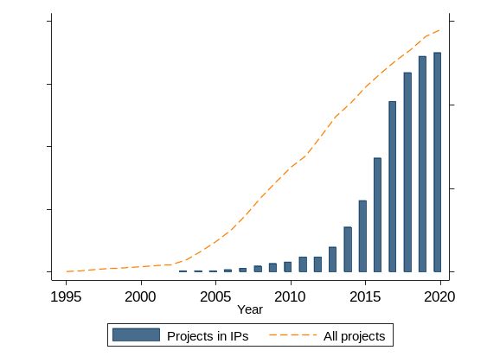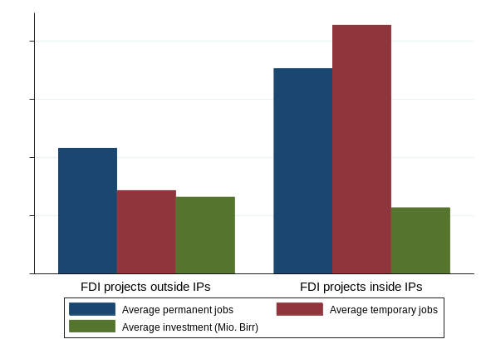
Notes: Author’s own compilation, based on project-level foreign investment data from the EIC. Both operational and (pre-) implementation projects are included. The left panel includes all foreign investment projects. The right panel includes only projects from the period 2013–2019 for which project-level data on investment and job creation are available.

Appendix Figure 2: Total IP Built-up Area of Ethiopia’s IPs over Time
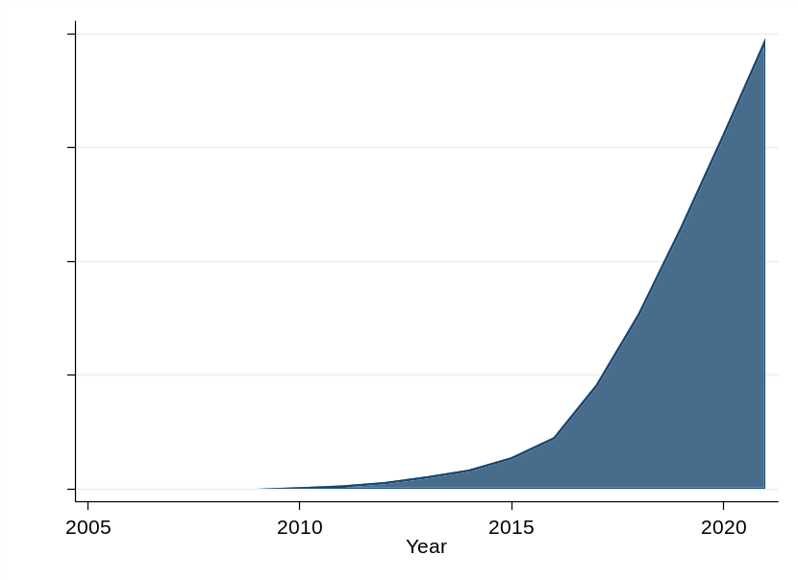
Notes: Author’s own compilation based on satellite imagery from Google Earth Pro. Total built-up area is measured in hectares and includes all physical structures such as factories and sheds that fall within the boundaries of an IP.

Additional main and robustness results
Appendix Table 1: Sectoral Classification
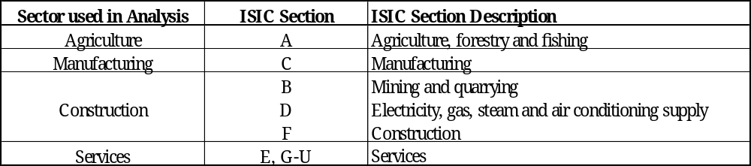
Notes: The sectoral classifications follow ISIC Revision 4.
Appendix Figure 3: Spatial Impact of IP Exposure on Type of Employer Firm
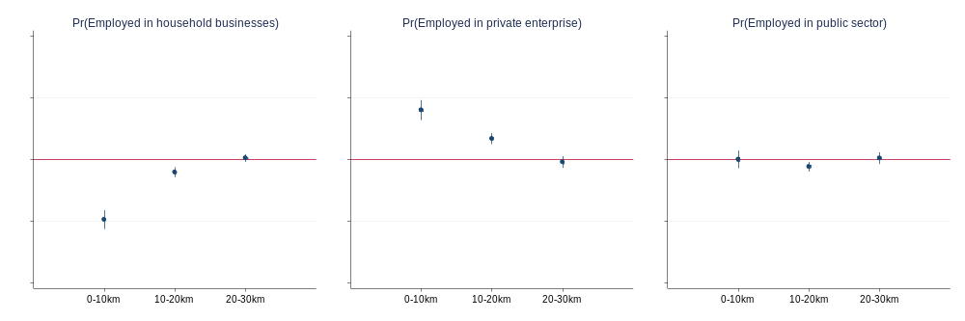
Note: Each plot shows the regression results of estimating specification (1), using as the dependent variable a dummy indicator for the type of employer firm of an individual. The blue dots indicate the coefficient estimates of $β_{1}$ to $β_{3}$ representing the effect of a 10 ha increase in built-up area in the corresponding 10 km distance bin, and the blue vertical lines indicate 95% confidence intervals. N=214,161 for the three other plots.
Appendix Figure 4: Spatial Impact of a 10 ha Increase in IP Built-up Area on Employment in Manufacturing Subsectors
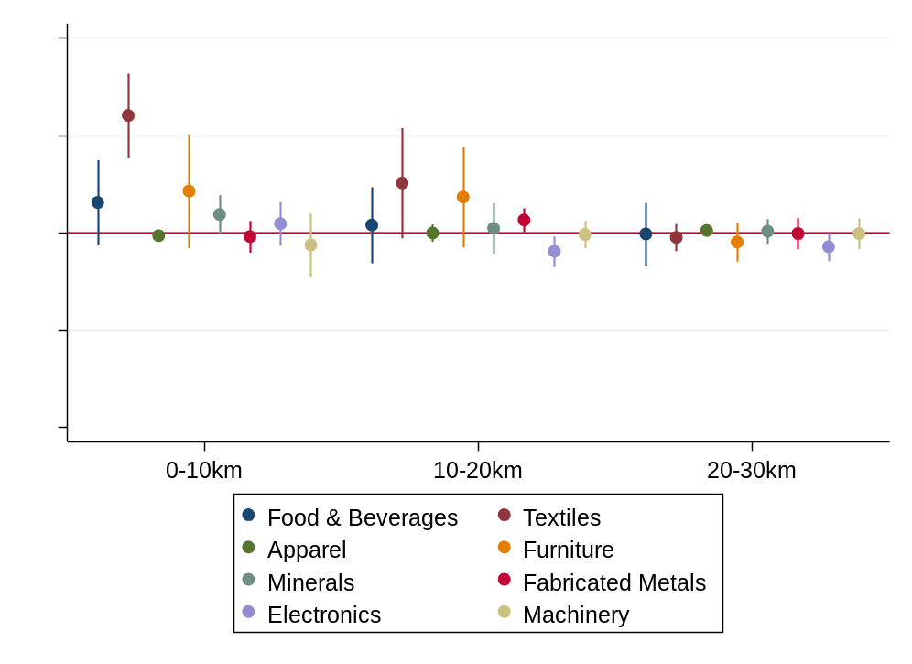
Notes: The reported results are based on estimating specification (1) using as the dependent variable a dummy indicator for the main 2-digit manufacturing subsectors. The sectoral classifications follow ISIC Revision 4 codes. Only individuals in employment are considered and are classified according to the 2-digit code of the firm in which they are employed. Divisions 10 and 11 are classified in Food & Beverages; division 13 in Textiles; division 14 in Apparel; divisions 16, 17, and 31 in Furniture; division 23 in Minerals; division 24 and 25 in Fabricated Metals; divisions 26 and 27 in Electronics; and division 28 in Machinery. Standard errors are reported in parentheses, clustered at district level. ***p < 0.01, **p < 0.05, *p < 0.1.
Appendix Figure 5: Spatial Impact of IP Expansion on Place of Work
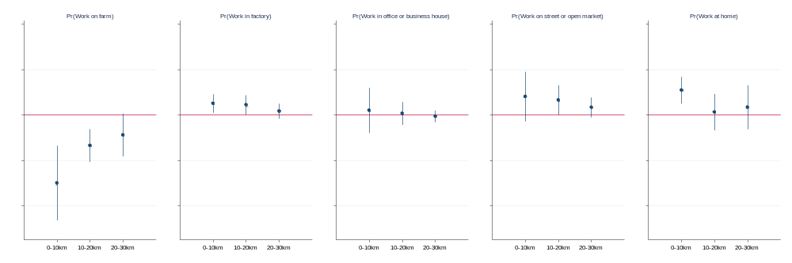
Note: Each plot shows the regression results of estimating specification (1), using as the dependent variable a dummy indicator for an individual’s place of work. The blue dots indicate the coefficients $β_{1}$ to $β_{3}$ representing the effect of a 10 ha increase in built-up area in the corresponding 10 km distance bin, and the blue vertical lines indicate 95% confidence intervals. N=208,648 for all five plots.

Appendix Figure 6: Spatial Impact of IP Expansion on Wages by Gender
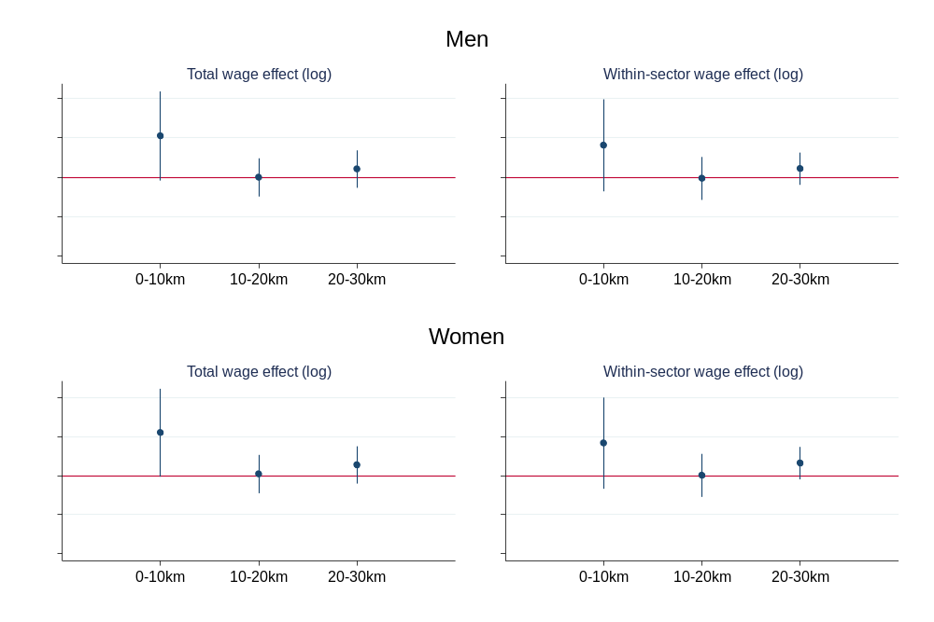
Note: Each plot shows the regression results of estimating specification (1) with interaction terms between the three treatment variables and a male dummy, using log wages as the dependent variable. Only individuals in wage employment are considered. The left-hand plot does not include 4-digit sector fixed effects (ISIC Rev. 4 codes), while the right-hand plot does. The blue dots indicate the coefficients estimates $β_{1}$ to $β_{3},$representing the effect of a 10 ha increase in built-up area in the corresponding 10 km distance bin, and the blue vertical lines indicate 95 per cent confidence intervals. N=52,522 for the left plot and N=45,454 for the right plot.
Appendix Table 2: Spatial Impact of IP Expansion on Type and Sector of Employment in the Last 12 Months
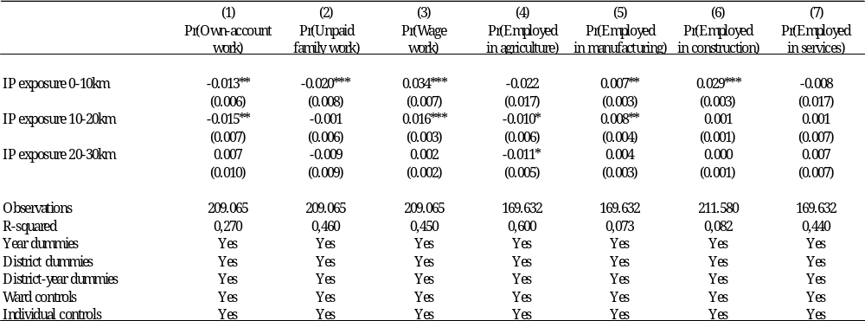
Notes: The reported results are based on estimating the district-level specification (1). The outcome variables refer to the type and sector of employment of individuals in the last 12 months. Only individuals in employment are considered. Standard errors are reported in parentheses, clustered at district level. ***p < 0.01, **p < 0.05, *p < 0.1.

Appendix Figure 7: Cumulative Job Creation and Capital Investment by IP, 2013–2019
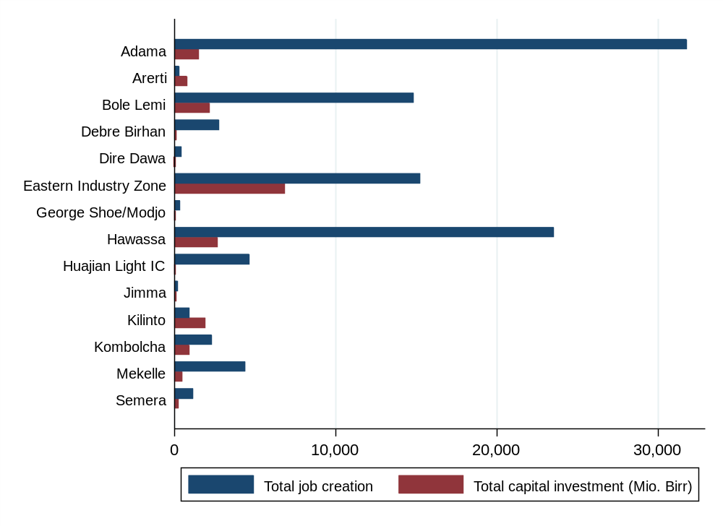
Note: Author’s own compilation, based on project-level foreign investment data from the EIC. Both operational and (pre-) implementation projects are included. We focus on the period 2013–2019 because project-level foreign investment data is not available other periods.
Appendix Table 3: Spatial Impact of Total IP Investment on Type and Sector of Employment
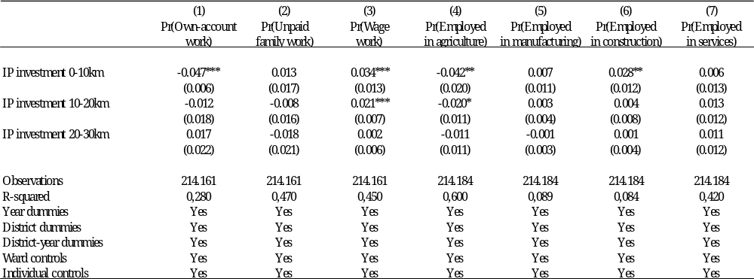
Notes: The reported results are based on estimating the district-level specification (1). The treatment variables capture the total IP job creation within the three distance bins to which an individual is exposed during the period 2013–2019. We apply the hyperbolic sine transformation to the treatment variables to account for their highly skewed distributions and the large number of zero values. Only individuals in employment are considered. Standard errors are reported in parentheses, clustered at district level. ***p < 0.01, **p < 0.05, *p < 0.1.

Appendix Table 4: Spatial Impact of Total IP Job Creation on Type and Sector of Employment
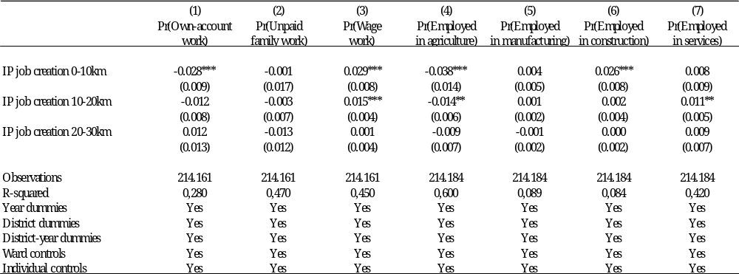
Notes: The reported results are based on estimating the district-level specification (1). The treatment variables capture the total IP job creation within the three distance bins to which an individual is exposed. We apply the hyperbolic sine transformation to the treatment variables to account for their highly skewed distributions and the large number of zero values. Only individuals in employment are considered. Standard errors are reported in parentheses, clustered at district level. ***p < 0.01, **p < 0.05, *p < 0.1.
Appendix Table 5: Spatial Impact of IP Exposure on Type and Sector of Employment, Treatment Group Only
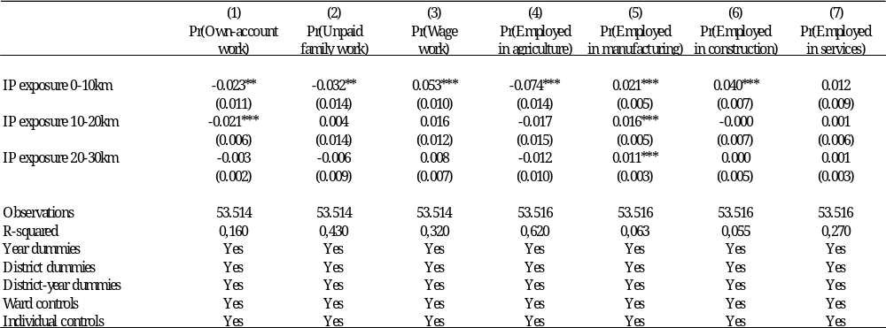
Notes: The reported results are based on estimating the district-level specification (1). The sample is restricted to individuals who are ultimately exposed to an IP in 2021, i.e. the treatment group. In addition, only individuals in employment are considered. Standard errors are reported in parentheses, clustered at district level. ***p < 0.01, **p < 0.05, *p < 0.1.
Appendix Table 6: Spatial Impact of IP Exposure on Type and Sector of Employment, Excluding Addis Ababa
Notes: The reported results are based on estimating the district-level specification (1). The sample is restricted to individuals living outside of Addis Ababa. In addition, only individuals in employment are considered. Standard errors are reported in parentheses, clustered at district level. ***p < 0.01, **p < 0.05, *p < 0.1.
Appendix Figure 8: Spatial Impact of IP Exposure on Migration
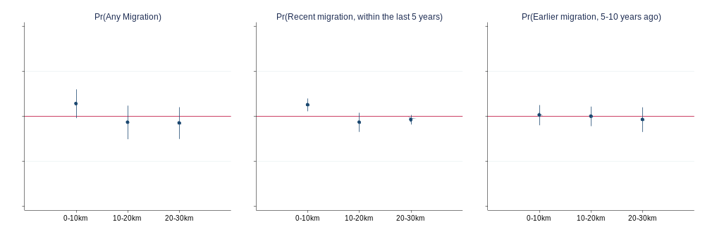
Note: Each plot shows the regression results of estimating specification (1), using dummies for the migration status as the dependent variable. Individuals are considered to be migrants if they have moved to their current place of residence within the last ten years. The blue dots indicate the coefficients estimates of $β_{1}$ to $β_{3},$representing the effect of a 10 ha increase in built-up area in the corresponding 10 km distance bin, and the blue vertical lines indicate 95 per cent confidence intervals. N=52,522 for the left plot and N=45,454 for the right plot.
Appendix Table 7: Spatial Impact of IP Exposure on Local Non-Migrants
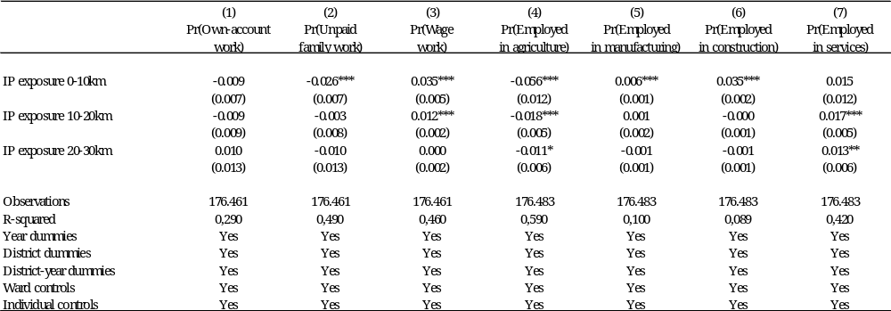
Notes: The reported results are based on estimating the district-level specification (1). The sample is restricted to local non-migrants. In addition, only individuals in employment are considered. Standard errors are reported in parentheses, clustered at district level. ***p < 0.01, **p < 0.05, *p < 0.1.

Ethiopia became the largest recipient of FDI in Africa among landlocked developing countries, with its total stock of FDI rising to $31.6 billion in 2021, accounting for about 31.8 per cent of the country’s GDP in 2021 (UNCTAD, 2022).
Here, T&A exports refer to the export of apparel and clothing accessories, both knitted or crocheted and non-knitted or non-crocheted, classified under Harmonized System codes 61 and 62.
In constructing their IP exposure measure from the built-up area in IPs, Tafese et al. (2025) exploit the fact that changes in the area covered by built-up area are a very good predictor of changes in economic activity over time, as has been shown by Bilicka and Seidel (2022).
SEZs are usually defined as clearly demarcated areas with a regulatory regime that is distinct from the rest of the economy (Lay and Tafese, 2020). Industrial parks are one type of SEZ that is prominent in Ethiopia, but others such as high-tech, free-trade or economic zones may be more important in other countries.
An exception to this is the study by Abagna et al. (2024), who don’t focus on an a single country but on Africa as a whole and use data from the from the Demographic and Health Surveys to examine the impact of SEZs on household wealth.
While Gallé et al. (2024) and Hyun and Ravi (2018) document shifts in employment from agriculture to manufacturing and services, Alkon (2018) and Görg and Mulyukova (2024) mostly find no such reallocation effects. However, the two former studies are arguably better suited for such reallocation analyses, as they incorporate data on informal production and employment from different data sources into their analyses.
For the sake of brevity, we limit the discussion to the Ethiopian context, although a related, rapidly growing literature has emerged focusing on the impact of FDI projects in Africa more generally (Hoekman et al., 2023; Hoekman and Sanfilippo, 2023; Lakemann et al., forthcoming; Mendola et al., 2021).
Abebe et al. (2022) focus only on 12 FDI openings between 2004 and 2010, while we consider much larger “shocks” to local labour markets that the establishment of IPs represents.
In another study, Ngoma (2023) focuses specifically on the import side and finds that increases in Chinese imports of intermediate inputs increase employment in manufacturing.
We identified the Ethiopian IPs and their characteristics from various sources from Ethiopian agencies such as the Industrial Parks Development Corporation, and cross-validated this with various other public sources including multilateral development organisations such as UNIDO and private investors.
The EIZ was established by the Chinese Qiyuan Group and the Bole Lemi IP was established in two phases. In general, Chinese government and private company officials have played a key role in supporting the development of Ethiopia’s legal and institutional framework for IP management. In addition, Chinese state-owned construction companies have established most of the private and public IPs in Ethiopia. For details on the development of IPs in Ethiopia and the role played by China see Tang (2022).
Another limiting factor for most local firms is that sheds in the IP can generally only be rented in foreign currency.
This includes both operational projects (57 per cent) and (pre-) implementation projects (43 per cent). We infer whether a foreign investment project is located within an IP from information on the zone in which it is located. While this information is not available for each project, the timing of the establishment of the IPs inferred in this way appears to be consistent with other public sources.
In particular, the GTP II, which was launched in 2015 with the aim of transforming Ethiopia into a lower-middle-income economy by 2025, has placed greater emphasis on the development of IPs across the country (National Planning Commission, 2016).
Ethiopia was quick to recognise the importance of FDI for the country’s economic and social development, and therefore integrated FDI attraction into its development policies as early as during the imperial regime from the early 1950s to 1974 (Gebreeyesus et al., 2022). However, the rise of the Derg regime in 1975 led to a hiatus in foreign investment promotion as the regime adopted a state-led socialist and command economic system and nationalised many private businesses (Newman, 2016). It was only after the Ethiopian People’s Revolutionary Democratic Front came to power in 1991 that various liberalisation measures such as privatisation, trade and investment opening, and market deregulation were again implemented (Gebreeyesus et al., 2022).
Ethiopia’s four public integrated agro-industrial parks, which focus on agro-processing, are developed by the regional IPDC in each region. Private IPs are developed by private foreign, mostly Chinese, investors.
We exclude the four integrated agro-industrial parks and the ICT park from our study because of their different economic focus. In addition, most of them are not yet operational.
The NLFS uses a two-stage stratified sampling design to select EAs (primary sampling unit) and households (secondary sampling unit). The stratification is based on the country’s regional states and the two city administrations, as well as on rural and urban areas. The sampling frame from which the EAs are randomly selected is derived from the population and housing censuses. While the general sampling approach is the same across the three survey waves, the specific selection methods and classification criteria have evolved slightly over time. More detailed information on the sampling frames, procedures, and descriptive statistics, can be found in the survey reports provided by the CSA for each wave.
As earnings data are not collected for self-employed own-account workers, workers in agriculture are underrepresented, while those in manufacturing, services, and construction are overrepresented. In the pooled sample, only about 3 per cent of workers in agriculture earn a wage, compared with 35 per cent, 46 per cent, and 60 per cent respectively in manufacturing, services, and construction.
While Ethiopia is administratively divided into four levels, a basic distinction is made between rural and urban areas. In rural areas, wards are villages, and in urban areas wards are neighbourhoods within towns. Towns have their own administrative code below the third district level and above the fourth ward level. As towns are already geographically small units and neighbourhoods within towns are often not geolocated, we use the geocoordinates of towns for urban areas. For rural areas, we use the geocoordinates of the actual villages.
To our knowledge, the Africa GeoPortal platform is the only source of geospatial data that includes administrative boundaries at the ward level for Ethiopia. An alternative source, the Humanitarian Data Exchange platform, only contains geospatial data at the district level. This is not detailed enough for our empirical analysis, as it includes district-year fixed effects that would absorb treatment effects if defined at this level.
There are significant differences in the success of extracting ward geocoordinates between waves. It worked best for the 2013 NLFS wave, where we were able to extract ward-level geocoordinates for 95 per cent of the NLFS wards, as the ward codes in the NLFS were largely identical to those in the Africa GeoPortal dataset. While the changes in administrative codes from the 2013 wave to the 2021 wave were most significant in the NLFS, we were still able to extract ward level geocoordinates for 85 per cent of the NLFS wards in 2021 by searching for their names in the Africa GeoPortal dataset and Google Maps. For 2005, however, we were only able to extract ward-level geocoordinates for 49 per cent of the wards because the names of the wards were not provided in the NLFS.
We include children under the legal working age of 15 in Ethiopia because it is not uncommon for them to work, especially in rural areas, where 47 per cent of them work compared to 8 per cent in urban areas (in the pooled sample). However, our results are robust when we consider only the working age population aged 15-65.
Households may fall into more than one distance bin as there is some concentration of IPs, particularly in and around Addis Ababa and Mekelle. For example, a household in the southern part of Addis may fall into a distance bin for the Kilinto IP and for the Bole Lemi IP.
We define distance bins at 10 km rather than smaller distances such as 5 km in order to have a sufficient number of treated observations in each bin.
For example, an individual living in a ward that does not live within 30 km of an IP will have a treatment value of 0 ha in all years. Similarly, an individual living within 10 km of an IP whose built-up area increases from 0 ha in 2013 to 50 ha in 2021, will have a treatment value for the 0-10 km distance bin of 0 ha in 2013 and 50 ha in 2021.
While 88 per cent of districts are available in at least two waves, this is only the case for 15 per cent of wards. Including ward fixed effects would therefore identify the impact of IPs from only the small subset of wards available in at least two waves.
This is similar to Gallé et al. (2024) who, in their setting where treatment varies at the district level, include interactions of baseline district characteristics with year fixed effects to account for shocks that may be correlated with pre-treatment differences between treated and control districts.
We cluster at the district-level rather than the ward-level – even though treatment varies at the ward level – because districts, unlike wards, are stable over time. In this way, we not only account for within-district correlation of errors, but also for district-level shocks over time. In fact, when we cluster at the ward level, standard errors are lower and therefore underestimated than when we cluster at the district level. The results are available upon request.
Note that a few individuals near the partially established EIZ and Bole Lemi were already exposed in 2013.
Although some individuals were exposed to the partially established EIZ and Bole Lemi in 2013, excluding these individuals does not change our results, suggesting that there is no violation of the assumption of homogeneous treatment effects. The results are available upon request.
There are also no economically significant differences in the impact of IPs on other dimensions of heterogeneity such as age and educational attainment. Results are available upon request.
68 per cent of export-oriented firms reported a decline in sales in a phone-survey in mid-2020.
Under AGOA, firms based in Ethiopia were able to export apparel and footwear products duty-free to the US market, by far the largest destination for Ethiopian T&A exports.
The 2021 NLFS wave was conducted from 25 January 2021 to 25 February 2021, i.e., the outcome variables referring to the last twelve months cover the period January/February 2020-January/February 2021.
In addition, only 0.2 per cent of individuals in our sample in the NLFS 2021 wave report that they did not work (in the last seven days) due to the outbreak of the pandemic, suggesting that it had little impact on employment status and patterns at the time of the survey.
As detailed project-level foreign investment data are not available after 2019, we take the total investment and total job creation up to 2019 as our IP exposure in 2021, the year of the last NLFS wave. As the number of foreign investment projects in IPs has slowed down recently, the alternative measures should still capture most of the total capital investment and job creation between 2013 and 2021. For 2005, we set the values for both IP measures to 0, as there had been no IPs in that year. Finally, several IPs (Asosa, Aysha, Bahir Dar, Bishoftu, DBL, Vogue, and Woda) had no approved foreign investment projects between by 2019 according to the EIC data, so there are fewer individuals exposed to IPs in the regressions using the alternative treatment variables.
Four IPs – Adama, Bole Lemi, EIZ, and Hawassa – account for the majority of capital investment and job creation in foreign investment projects between 2013 and 2021.
For large values, as is the case in our context for cumulative investment and job creation, the coefficients on the sine-transformed variables are interpreted as log-transformed variables. For example, the coefficient of 0.046 in column 1 of the upper table in Appendix Table 3 tells us that a 1% increase in cumulative investment increases the probability of own-account work by 0.00046 percentage points. This represents a significant economic impact, with foreign investment increasing substantially between 2005 and 2021.
We still prefer to use actual built-up area as a proxy for economic activity in IPs in our baseline specification because it is superior to the cumulative investment and job creation measures due to several shortcomings in the project-level foreign investment data from which they are derived. First, although the data include the date of approval of investment projects, we do not know exactly when they became operational and, for projects in the (pre-)implementation phase, whether they became operational at all. Second, the project-level investment data are likely to miss some foreign investment projects in IPs, as we infer whether a project is in an IP or not from a single variable that is not clearly defined and has many missing values. Third, project-level investment and job creation figures are likely to capture only initial greenfield investment and job creation, but not follow-on investment and job creation. In contrast, our measure of IP built-up area captures all three aspects.
While migrants make up 18 per cent of the total sample, they account for 28 per cent of workers in the T&A sector (ISIC rev. 4 2-digit codes 13 to 15) and 29 per cent of the stationary plant and machine operators (ISCO rev. 08 2-digit code 81).

